**Jenkins Installation::**

**GIT,Maven,Sonarqube,Nexus,,Ansible,Docker,Kubernetes,Prometheus**

1. Install Java (Check Java version using Java –version)
2. Need to set homePath of Java under **.bash_profile** (So find the JRE path)
3. Navigate to Jenkins home page (LTS (long term support) support)
4. Take the Url and install ,,yum install Jenkins.
5. Start the Jenkins service using **service jenkins start**
6. Access the Jenkins application from the browser on the IP:8080
7. Manage Jenkins🡪 Global tool configuration🡪 add JDK ,give name and JAVA_HOME Path.

ON RHEL:

#!/bin/bash

sudo wget -O /etc/yum.repos.d/jenkins.repo \

https://pkg.jenkins.io/redhat-stable/jenkins.repo

sudo rpm --import https://pkg.jenkins.io/redhat-stable/jenkins.io.key

sudo yum upgrade

sudo yum install jenkins java-1.8.0-openjdk-devel -y

sudo systemctl daemon-reload

service jenkins start

cat /var/lib/jenkins/secrets/initialAdminPassword

**To change port number:**

/etc/sysconfig/**jenkins**

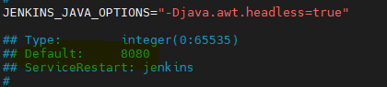

---------------------------------------------------------------------------

**GIT installation and setup::**

1. Install GIT using yum install GIT –y or apt-get install git –y
2. Check git version using “GIT –version”

**Integration with Jenkins:**

1. Install GIT plugin ,go to manage jekins🡪Manage plugins (**GIT HUB and GIT HUB integrator plugins**)
2. Manage Jenkins🡪Global tool configuration-> the git name and the path will be updated automatically ,if not add it.

--------------------------------------------------------------------------------------------

**Maven Installation and Integration::**

**https://tecadmin.net/install-apache-maven-on-centos/**

1. Install Java
2. Navigate to Apache maven homepage
3. Select the tar file
4. Untar it using **(tar –xvzf filename)**
5. Set M2 and M2_Home path in **.bash_profile**

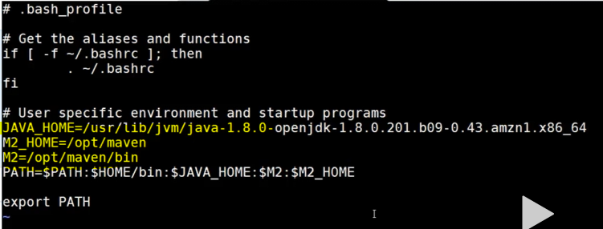

1. Check the maven version using “mvn –version”

**Integration with Jenkins:**

1. Manage Jenkins🡪 manage plugins🡪 install “ Maven invoker” plugin.
2. Setup maven path ,,,,Manage Jenkins🡪 Global tool configuration
3. In the maven section give Maven name and MAVEN_HOME path.

--------------------------------------------------------------------------

Nexus:

1. Install “Nexus artifact uploader plugin” and “Build time stamp” plugin.
2. While configuring job “”

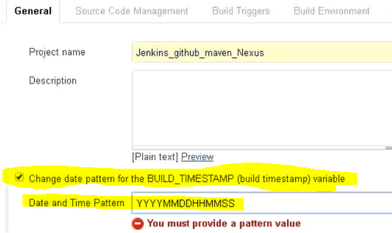

1. In the Build section provide Nexus details

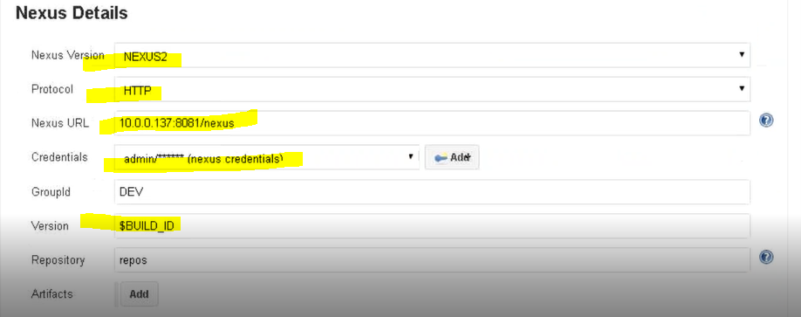

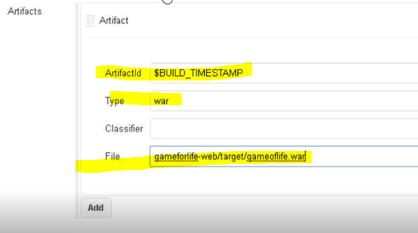

**How to integrate Docker with Jenkins?**

Step 1 − Go to your Jenkins dashboard and click Manage Jenkins.

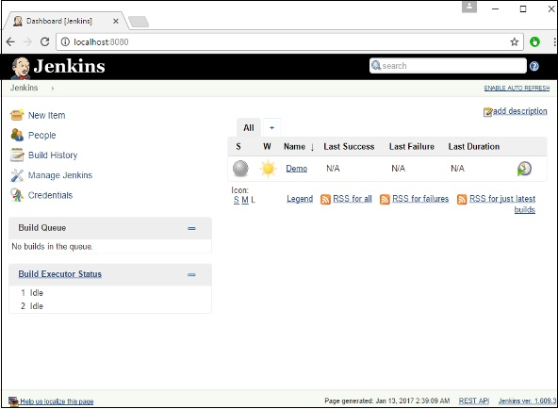

Step 2 − Go to Manage Plugins.

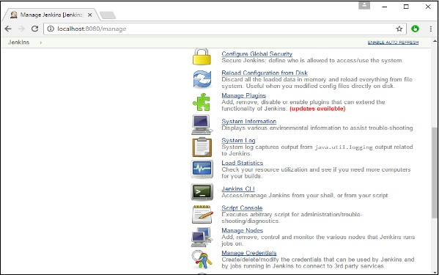

Step 3 − Search for Docker plugins. Choose the Docker plugin and click the Install without restart button.

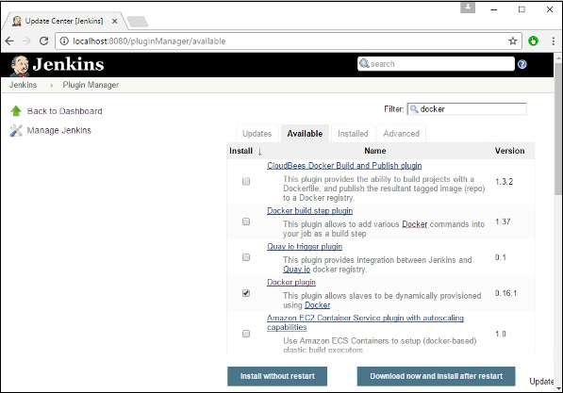

Step 4 − Once the installation is completed, go to your job in the Jenkins dashboard. In our example, we have a job called Demo.

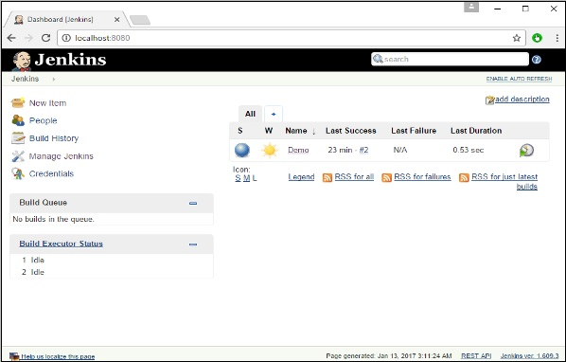

Step 5 − In the job, when you go to the Build step, you can now see the option to start and stop containers.

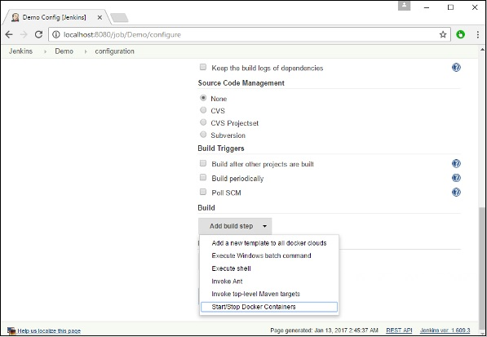

Step 6 − As a simple example, you can choose the further option to stop containers when the build is completed. Then, click the Save button.

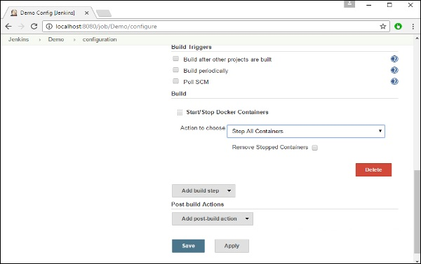

Now, just run your job in Jenkins. In the Console output, you will now be able to see that the command to Stop All containers has run.

